UNIT 4

It is a software that works as an interface between a user and the [computer](http://ecomputernotes.com/fundamental/introduction-to-computer/what-is-computer) hardware. The primary objective of an [*operating system*](http://ecomputernotes.com/fundamental/disk-operating-system/what-is-operating-system) is to make computer system convenient to use and to utilize computer hardware in an efficient manner. The operating system performs the basic tasks such as receiving input from the keyboard, processing instructions and sending output to the screen.

The operating system manages a computer's hardware resources, including:

* Input devices such as a keyboard and mouse.
* Output devices such as display monitors, printers and scanners.
* Network devices such as modems, routers and network connections.
* Storage devices such as internal and external drives.

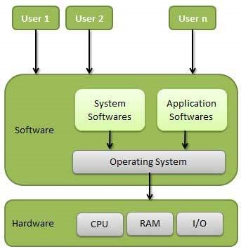

Following are some of important functions of an operating System.

* Memory Management
* Processor Management
* Device Management
* File Management
* Security
* Control over system performance
* Job accounting
* Error detecting aids
* Coordination between other software and users

**Memory Management**

Memory management refers to management of Primary Memory or Main Memory.

* In multiprogramming, the OS decides which process will get memory when and how much.
* Allocates the memory when a process requests it to do so.
* De-allocates the memory when a process no longer needs it or has been terminated.

**Processor Management**

In multiprogramming environment, the OS decides which process gets the processor when and for how much time. This function is called process scheduling. An Operating System does the following activities for processor management −

* Keeps tracks of processor and status of process. The program responsible for this task is known as traffic controller.
* Allocates the processor (CPU) to a process.
* De-allocates processor when a process is no longer required.

**Device Management**

An Operating System manages device communication via their respective drivers. It does the following activities for device management −

* Keeps tracks of all devices. Program responsible for this task is known as the I/O controller.
* Decides which process gets the device when and for how much time.
* Allocates the device in the efficient way.
* De-allocates devices.

**File Management**

A file system is normally organized into directories for easy navigation and usage. These directories may contain files and other directions.

An Operating System does the following activities for file management −

* Keeps track of information, location, uses, status etc. The collective facilities are often known as file system.
* Decides who gets the resources.
* Allocates the resources.
* De-allocates the resources.

**Other Important Activities**

Following are some of the important activities that an Operating System performs −

* Security − By means of password and similar other techniques, it prevents unauthorized access to programs and data.
* Control over system performance − Recording delays between request for a service and response from the system.
* Job accounting − Keeping track of time and resources used by various jobs and users.
* Error detecting aids − Production of dumps, traces, error messages, and other debugging and error detecting aids.
* Coordination between other softwares and users − Coordination and assignment of compilers, interpreters, assemblers and other software to the various users of the computer systems.

TYPES OF OPERATING SYSTEM

**1. Single-user, single task -** As the name implies, this operating system is designed to manage the computer so that one user can effectively do one thing at a time. The Palm OS for Palm handheld computers is a good example of a modern single-user, single-task operating system. Ex: DOS, WINDOWS 3X, WINDOWS 95/97/98

2. **A Multi-user operating system** is a computer operating system which allows multiple users to access the single system with one operating system on it. It is generally used on large mainframe computers.

Example: Linux, Unix, Windows 2000, Ubuntu, Mac OS etc.,

**Types of Multi-user Operating System**

A multi-user operating system is of 3 types which are as follows:

1**. Distributed Systems**: in this, different computers are managed in such a way so that they can appear as a single computer. So, a sort of network is formed through which they can communicate with each other.  
2**. Time-sliced Systems**: in this, a short period is assigned to each task, i.e. each user is given a time slice of the CPU time. As we know these time slices are tiny, so it appears to the users that they all are using the mainframe computer at the same time.  
3. **Multiprocessor Systems**: in this, the operating system utilizes more than one processor.

|  |  |
| --- | --- |
| **Single user Operating System** | **Multi-user Operating System** |
| It is an operating system in which the user can manage one thing at a time effectively. | It is an operating system in which multiple users can manage multiple resources at a time |
| **Example**: MS DOS | **Example**: Linux, Unix, windows 2000, windows 2003 etc. |
| Single user Operating System has two types: Single user Single task Operating System and Single user Multi task Operating System. | It is of three types: time-sharing operating system, distributed operating system and multiprocessor system. |
| It is simple. | It is complex. |
| It provides a platform for one user at a time. | It provides controlled access for the number of users by maintaining a [database](http://ecomputernotes.com/fundamental/what-is-a-database/advantages-and-disadvantages-of-dbms) of known users. |
| If another user wants to access the computer resources, then he/she has to wait until the current process completes. | There is no need to wait for accessing the computer resources. |
| This type of operating system is used for single user. | This type of operating system is used for multiple users. |
| It is the operating system which maximum people use on their [personal computer](http://ecomputernotes.com/fundamental/introduction-to-computer/personal-computer)s or [laptop](http://ecomputernotes.com/fundamental/introduction-to-computer/laptop-computer)s. | It is the operating system which is most of the time used in mainframe computers. |
| In this, there is no need to take care of balance between users. | In this, we have to take care of balance between users so that if one problem arises with one user does not affect other users also. |

3. Multiprogramming

Multiprogramming is the ability for more than one user to use the computer at a time using a single CPU. The idea is to effectively utilize the processor to create multiple ready-to-run processes with each process belongs to different user. If the current process stalls for some reason, because it has to wait for some particular event, the operating system allocates the CPU to another process in the queue. The whole operation is facilitated by multiprogramming operating systems to maximize CPU utilization so that to reduce the idle time of the CPU. The idea is to keep the CPU busy for as long as possible.  
  
4. Multitasking

Multitasking means concurrent execution of multiple processes by one user on the same computer utilizing multiple CPUs. For example, in a multitasking operating system, you may work on a word document with one program [while](http://www.differencebetween.net/technology/difference-between-while-and-do-while-loop/) listening to music as the same time with another program. Multitasking is effective when programs on a compute require a high degree of parallelism. It is based on the concept of time sharing because multiple processes or tasks can be switched accordingly at a regular interval of time, so that the users get the idea that they are performed concurrently.  
  
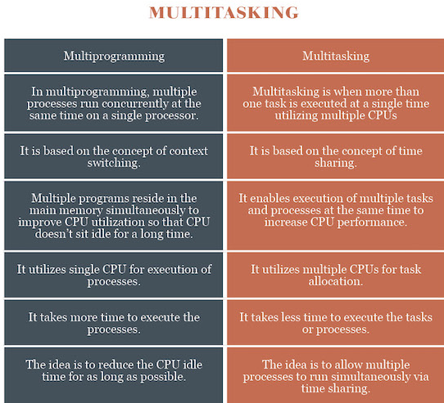

Batch operating system

The users of a batch operating system do not interact with the computer directly. Each user prepares his job on an off-line device like punch cards and submits it to the computer operator. To speed up processing, jobs with similar needs are batched together and run as a group. The programmers leave their programs with the operator and the operator then sorts the programs with similar requirements into batches.

The problems with Batch Systems are as follows −

* Lack of interaction between the user and the job.
* CPU is often idle, because the speed of the mechanical I/O devices is slower than the CPU.
* Difficult to provide the desired priority.

Time-sharing operating systems

Time-sharing is a technique which enables many people, located at various terminals, to use a particular computer system at the same time. Time-sharing or multitasking is a logical extension of multiprogramming. Processor's time which is shared among multiple users simultaneously is termed as time-sharing.

The operating system uses CPU scheduling and multiprogramming to provide each user with a small portion of a time. Computer systems that were designed primarily as batch systems have been modified to time-sharing systems.

Advantages of Timesharing operating systems are as follows −

* Provides the advantage of quick response.
* Avoids duplication of software.
* Reduces CPU idle time.

Disadvantages of Time-sharing operating systems are as follows −

* Problem of reliability.
* Question of security and integrity of user programs and data.
* Problem of data communication.

Parallel Processing:

Parallel processing is a method in computing of running two or more processors (CPUs) to handle separate parts of an overall task. Breaking up different parts of a task among multiple processors will help reduce the amount of time to run a program. Any system that has more than one CPU can perform parallel processing, as well as multi-core processors which are commonly found on computers today.

Parallel processing is commonly used to perform complex tasks and computations. Data scientists will commonly make use of parallel processing for compute and data-intensive tasks.

Parallel systems are more difficult to program than computers with a single processor because the architecture of parallel computers varies accordingly and the processes of multiple CPUs must be coordinated and synchronized.

Flynn (Classification or Types of Parallel Processing) has classified the computer systems based on parallelism in the instructions and in the data streams. These are:

1. **Single instruction stream, single data stream (SISD).**

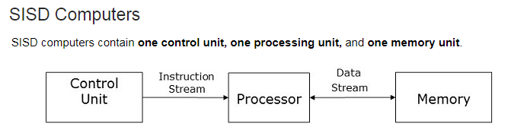

2**. Single instruction stream, multiple data stream (SIMD).**

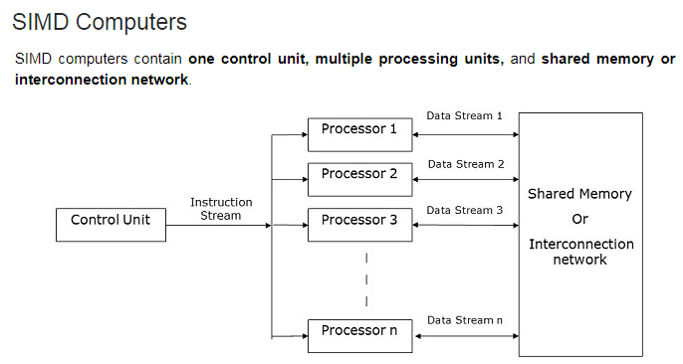

3. **Multiple instruction streams, single data stream (MISD).**

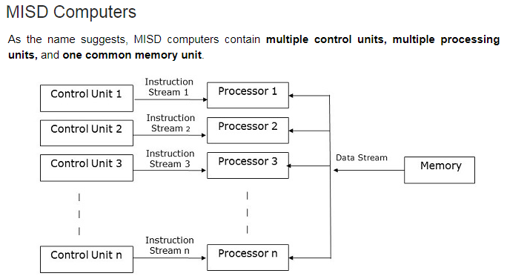

4. **Multiple instruction stream, multiple data stream (MIMD).**

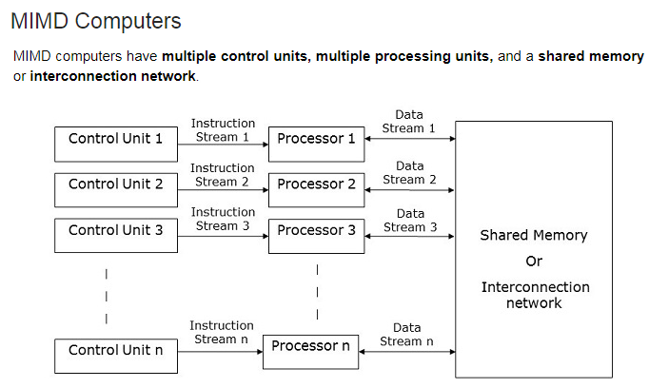

**Distributed processing**

Distributed processing is a setup in which multiple individual central processing units (CPU) work on the same programs, functions or systems to provide more capability for a computer or other device.

Originally, conventional microprocessors involved just one CPU on a chip. As microprocessor engineering evolved, manufacturers discovered that to speed up processes, more than one processor could be combined on a single unit.

Distributed processing also can be used as a rough synonym for parallel processing, in which programs are made to run more quickly with multiple processors. With the strategy of including more than one processor on a microprocessor chip, hardware users also can string multiple computers together to implement parallel processing with applications known as distributed processing software.

**Mobile Devices Operating System**

A mobile operating system (mobile OS) is an OS built exclusively for a mobile device, such as a smartphone, personal digital assistant (PDA), tablet or other embedded mobile OS. Popular mobile operating systems are Android, Symbian, iOS, BlackBerry OS and Windows Mobile.

A mobile OS is responsible for identifying and defining mobile device features and functions, including keypads, application synchronization, email, thumbwheel and text messaging. A mobile OS is similar to a standard OS (like Windows, Linux, and Mac) but is relatively simple and light and primarily manages the wireless variations of local and broadband connections, mobile multimedia and various input methods.

With the exception of Android (developed by Google), mobile operating systems are developed by different mobile phone manufacturers, including Nokia (Symbian, MeeGo, Maemo); Apple (Apple iOS); Research In Motion (RIM) (BlackBerry OS); Microsoft (Windows Mobile, Windows Phone) and Samsung (Palm WebOS and bada). Android, LiMo, Maemo, Openmoko and Qt Extended (Qtopia) are based on the Linux open-source OS.

**File Allocation Table (FAT & FAT 32)**

A file allocation table (FAT) is a file system developed for hard drives .It is used by the operating system (OS) to manage files on hard drives and other computer systems. It is often also found on in flash memory, digital cameras and portable devices. It is used to store file information on hard drive.

FAT was the primary file system used in all of Microsoft's consumer operating systems from MS-DOS through Windows ME. Even though FAT is still a supported option on Microsoft's newer operating systems, NTFS is the primary file system used these days.

* The first FILE system was develop by Tim Paterson in 1984 for DOS operating System called as FAT 12.
* The second implementation of FAT was FAT16, first introduced in 1986 in PC DOS 3.0 and MS-DOS 3.0.A slightly more improved version of FAT16, called FAT16B,
* FAT32 is the latest version of the FAT file system. It was introduced in 1996 for Windows 95 OSR2 / MS-DOS 7.1 users and was the primary file system for consumer Windows versions through Windows ME.
* exFAT, first introduced in 2006, is yet another file system created by Microsoft although it's not the "next" FAT version after FAT32.exFAT is primarily intended to be used on portable media devices like flash drives, SDHC and SDXC cards, etc.

**NTFS**

NTFS ( New Technology File System) is the file system that the Windows NT operating system uses for storing and retrieving files on a hard disk.

Features of NTFS include:

* Use of a b-tree directory scheme to keep track of file clusters
* Support for very large files (up to 2 to the 64th power or approximately 16 billion bytes in size)
* An access control list (ACL) that lets a server administrator control who can access specific files
* Integrated file compression
* Support for long file names.
* Data security on both removable and fixed disks.

**Difference Between FAT and NTFS**

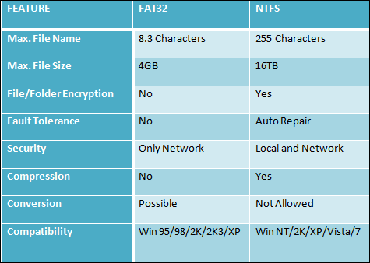

**Drives, files & directory structure**

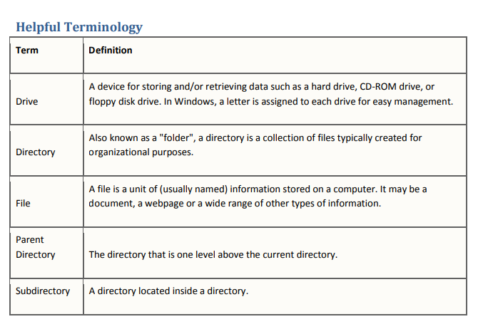

Drives, Directories & Files

1. Start by double clicking on "Start" then "Computer."
2. Once this window is open, you should see a listing of your "drives". Your drives are like the main file
3. cabinet which stores all of the directories and files. In many cases you'll have only one "local" disk/drive.
4. If you have more than one, your "C" drive is the most common letter given to the default local drive.

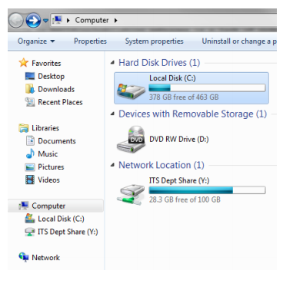

2. Double click on your local disk/drive. (This is usually your "C" drive). You should see a listing of directories and files. Click on Users.

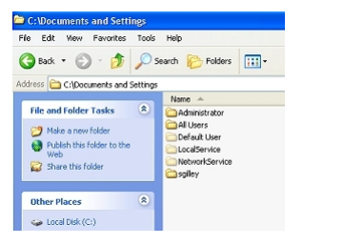

3.If you're using Windows XP or 2000, double click on the sub-directory called "Documents and Settings." Your view now should look something like the image below.

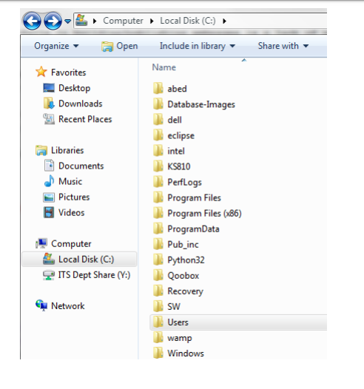

3.Double click on the directory with your user name. It's important to note that EACH user will have their own "My Documents" folder, so be sure the one you find is your own!. So my path to "My Documents" is "C:\users\its-pdean1\My Documents".

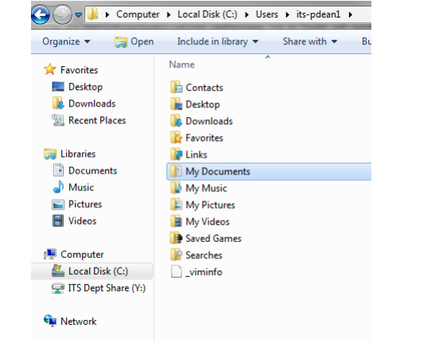

# Structures of Directory in Operating System

What is a directory?

Directory can be defined as the listing of the related files on the disk. The directory may store some or the entire file attributes.

To get the benefit of different file systems on the different operating systems, A hard disk can be divided into the number of partitions of different sizes. The partitions are also called volumes or mini disks.

Each partition must have at least one directory in which, all the files of the partition can be listed. A directory entry is maintained for each file in the directory which stores all the information related to that file.

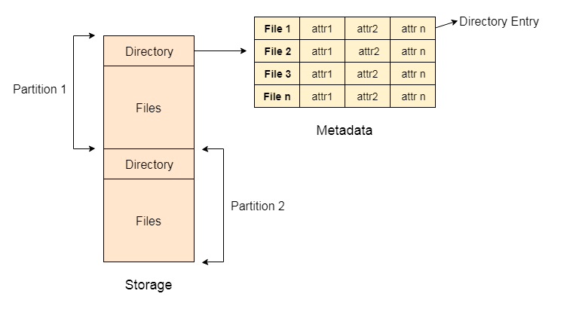

A directory can be viewed as a file which contains the Meta data of the bunch of files.

Every Directory supports a number of common operations on the file:

1. File Creation
2. Search for the file
3. File deletion
4. Renaming the file
5. Traversing Files
6. Listing of files

# Single Level Directory

The simplest method is to have one big list of all the files on the disk. The entire system will contain only one directory which is supposed to mention all the files present in the file system. The directory contains one entry per each file present on the file system.

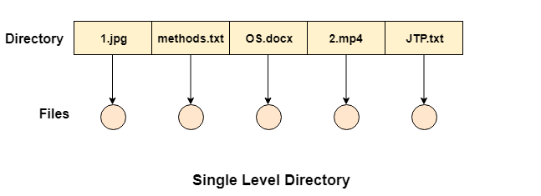

This type of directories can be used for a simple system.

## Advantages

1. Implementation is very simple.
2. If the sizes of the files are very small then the searching becomes faster.
3. File creation, searching, deletion is very simple since we have only one directory.

## Disadvantages

1. We cannot have two files with the same name.
2. The directory may be very big therefore searching for a file may take so much time.
3. Protection cannot be implemented for multiple users.
4. Choosing the unique name for every file is a bit complex and limits the number of files in the system because most of the Operating System limits the number of characters used to construct the file name.

# Two Level Directory

In two level directory systems, we can create a separate directory for each user. There is one master directory which contains separate directories dedicated to each user. For each user, there is a different directory present at the second level, containing group of user's file. The system doesn't let a user to enter in the other user's directory without permission.

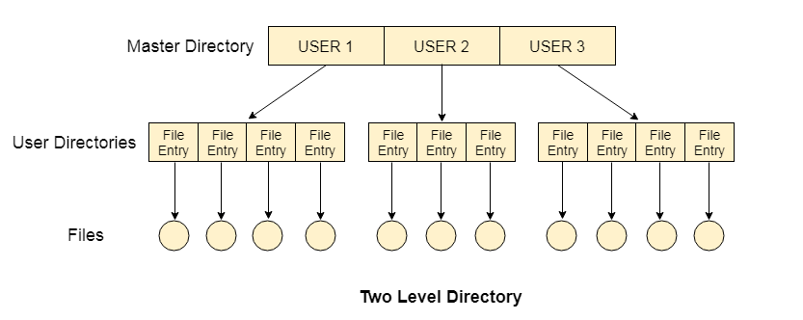

## Characteristics of two level directory system

1. Each files has a path name as ***/User-name/directory-name/***
2. Different users can have the same file name.
3. Searching becomes more efficient as only one user's list needs to be traversed.
4. The same kind of files cannot be grouped into a single directory for a particular user.

# Tree Structured Directory

In Tree structured directory system, any directory entry can either be a file or sub directory. Tree structured directory system overcomes the drawbacks of two level directory system. The similar kind of files can now be grouped in one directory.

Each user has its own directory and it cannot enter in the other user's directory. However, the user has the permission to read the root's data but he cannot write or modify this. Only administrator of the system has the complete access of root directory.

Searching is more efficient in this directory structure.

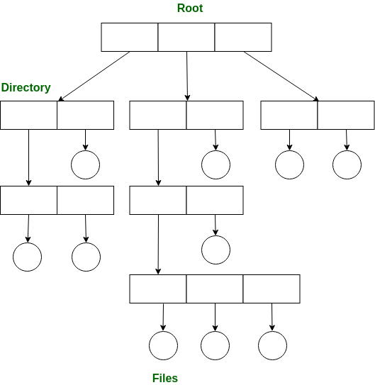

A tree structure is the most common directory structure. The tree has a root directory, and every file in the system have a unique path.

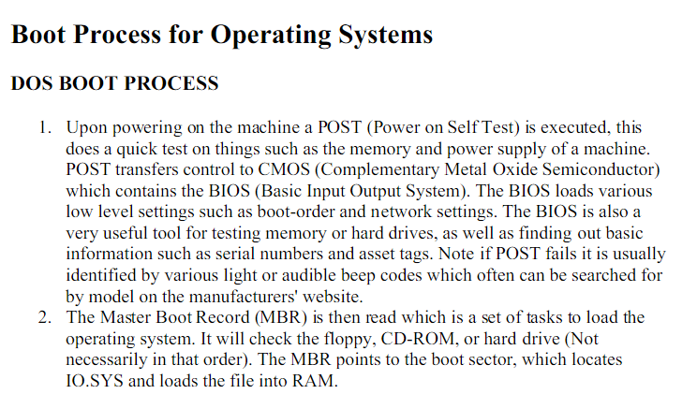



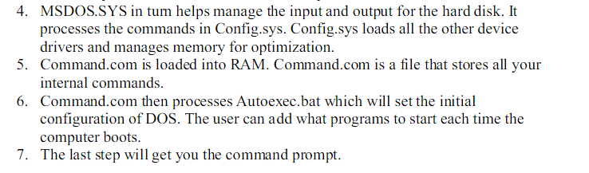

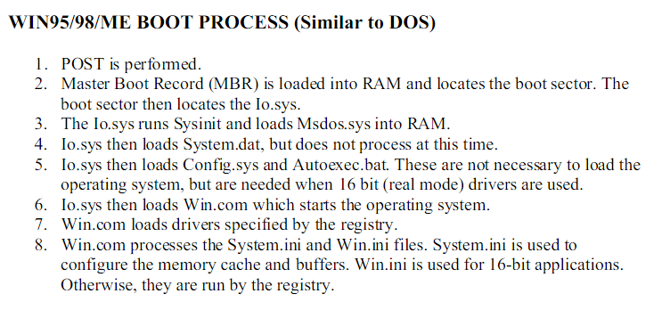

Linux and Windows Operating System:

| **S.NO** | **LINUX** | **WINDOWS** |
| --- | --- | --- |
| 1. | Linux is a open source operating system. | While windows are the not the open source operating system. |
| 2. | Linux is free of cost. | While it is costly. |
| 3. | It’s file name case-sensitive. | While it’s file name is case-insensitive. |
|  |  |  |
| 4. | Linux is more efficient in comparison of windows. | While windows are less efficient. |
| 5. | There is forward slash is used for Separating the directories. | While there is back slash is used for Separating the directories. |
| 6. | Linux provides more security than windows. | While it provides less security than linux. |

iOS operating System

iOS (formerly iPhone OS) is a mobile operating system created and developed by Apple Inc. exclusively for its hardware. It is the operating system that presently powers many of the company's mobile devices, including the iPhone, and iPod Touch; it also powered the iPad prior to the introduction of iPadOS in 2019. It is the second most popular mobile operating system globally after Android.

Originally unveiled in 2007 for the iPhone, iOS has been extended to support other Apple devices such as the iPod Touch (September 2007) and the iPad.

Android Operating System

* The Android operating system was developed by Google (GOOGL​) for use in all of its touchscreen devices, tablets, and cell phones.
* This operating system was first developed by Android, Inc., a software company located in Silicon Valley before it was acquired by Google in 2005.
* While the Android source code is released in an open-source format to help advance open standards across mobile devices, it is still packaged with proprietary software when sold on handset devices.

**An open source operating system :**

An **open source operating system** is an **operating system** whose code has been made publicly and freely available to anyone who wants to see it and modify.

Open source software is different. Its authors make its source code available to others who would like to view that code, copy it, learn from it, alter it, or share it.

Examples of Open sourse operating System.

Ubuntu, Mozilla firefox, Mysql, Python, BitTorrent, Blender.

### List of Advantages and Disadvantages of Open Source Software

* It’s  free – it has been estimated that open source software collectively saves businesses $60 billion a year. These days for virtually every paid for proprietary software system you will find an open source version.
* It’s continually evolving in real time as developers add to it and modify it, which means it can be better quality and more secure and less prone to bugs.
* Using open source software also means you are not locked into using a particular vendor’s system that only work with their other systems.
* You can modify and adapt open source software for your own business requirements, something that is not possible with proprietary systems.

**Disadvantages:**

* Because there is no requirement to create a commercial product that will sell and generate money, open source software can tend to evolve more in line with developers’ wishes than the needs of the end user.
* For the same reason, they can be less “user-friendly” and not as easy to use because less attention is paid to developing the user interface.
* There may also be less support available for when things go wrong – open source software tends to rely on its community of users to respond to and fix problems.
* Although the open source software itself is mostly free, there may still be some indirect costs involved, such as paying for external support.
* Although having an open system means that there are many people identifying bugs and fixing them, it also means that malicious users can potentially view it and exploit any vulnerabilities.

#### Virus

A computer virus is a piece of software that can 'infect' a computer, install itself and copy itself to other computers, without the users knowledge or permission. It usually attaches itself to other computer programs, data files, or the boot sector of a Hard drive.

**Various types of virus :**

1. **File Virus :**This type of virus infects the system by appending itself to the end of a file.
2. **Boot sector Virus :**It infects the boot sector of the system, executing every time system is booted and before operating system is loaded. It infects other bootable media like floppy disks. These are also known as **memory virus** as they do not infect file system.
3. **Macro Virus :**Unlike most virus which are written in low-level language(like C or assembly language), these are written in high-level language like Visual Basic. These viruses are triggered when a program capable of executing a macro is run. For example, macro virus can be contained in spreadsheet files.
4. **Source code Virus :**It looks for source code and modifies it to include virus and to help spread it.
5. **Encrypted Virus :**In order to avoid detection by antivirus, this type of virus exists in encrypted form. It carries a decryption algorithm along with it. So the virus first decrypts and then executes.
6. **Tunneling Virus :**This virus attempts to bypass detection by antivirus scanner by installing itself in the interrupt handler chain.
7. **Multipartite Virus :**This type of virus is able to infect multiple parts of a system including boot sector,memory and files. This makes it difficult to detect and contain.

#### Malware

Malware is short for **mal**icious soft**ware**. Malware is the name given to any type of software that could harm a computer system, interfere with and gather a user's data, or make the computer perform actions without the owner's knowledge or permission.

#### Worm

Unlike a virus, a worm, is a standalone piece of malicious software that replicates itself in order to spread to other computers. It often uses a computer network to spread itself, relying on security flaws on the target system to allow access.

#### Trojan horse

A type of malware that uses malicious code to install software that seems ok, but is hidden to create back doors into a system typically causing loss or theft of data from an external source.

**Antivirus:**

Antivirus software is a type of program designed and developed to protect computers from malware like viruses, computer worms, spyware, keyloggers and such. Antivirus programs function to scan, detect and remove viruses from your computer. There are many versions and types of anti-virus programs that are on the market. However, the prime objective of any antivirus program is to protect computers and remove viruses once detected.

Types of Antivirus:

1. AVG

AVG is one of the most popular antivirus programs that can be obtained for free, and it’s easy to download directly from the internet. In addition to not taking up a significant amount of space on a hard drive, it can also work with a number of different Windows operating systems.

2. McAfee

McAfee VirusScan has been the second most popular antivirus program on the market for years. It provides spyware and virus protection within one program, rather than separately as many other programs do.

3. Norton

There are a number of Norton antivirus programs available. They have quickly proven themselves to be a market leader when it comes to computer system security, with their products available from a range of different electronics supply stores.

4. Kaspersky

Russian-developed Kaspersky is not the most popular of all the antivirus protection programs; many people have probably never heard of them. However, they still provide a very effective product for protection against viruses, spyware, and Trojans.

5. Ad Aware

This software by Lavasoft is another antivirus program that provides protection against a large number of cyber security threats that arise from using the Internet. They offer different levels of protection according to how much you want to spend in a one-off payment for the program.

Virus Detection and Prevention:

A **virus scan** is the process of using anti-**virus** software to **scan** and identify viruses in a computing device. It is an information security process that aims to review and identify threatening viruses and programs. Firewall and Antivirus are the Prevention Methods.

Firewall

A firewall is a software or hardware system designed to prevent unauthorized access to an individual computer or network of computers. They are used mostly as a first line of defense to protect your device or network from online threats such as hackers, viruses, Trojans, and worms.

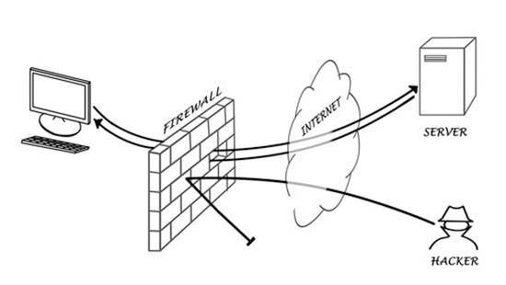

Every time you are connected to the Internet, your computer is exposed to all sorts of dangerous programs and malicious people that want to infiltrate your computer to steal your personal information, send spam emails to your inboxes, or use your computer to launch attacks on other computers.

A good firewall system blocks attackers from trying to infiltrate your system and prevents your data and information from flowing out to the bad guys.

#### Some examples related to virus attacks

#### Trojan horse

A type of malware that uses malicious code to install software that seems ok, but is hidden to create back doors into a system typically causing loss or theft of data from an external source.

#### Spyware

Spyware is software that aids in gathering information about a person or organization without their knowledge, they can monitor and log the activity performed on a target system, like log key strokes, or gather credit card and other information.

#### Adware

Adware is software which can automatically causes pop-up and banner adverts to be displayed in order to generate revenue for its author or publisher. A lot of freeware will use Adware but not always in a malicious way, if it was malicious, it would then be classed as spyware or malware.